**An HR benefits initiative**

**Employee Benefit Manual**

**Policy Year: 2025**

**-**

**26**

www.prudentbrokers.com



**UST**

**Group Medical Coverage**

**Employee Session Deck**

**Disclaimer**

This benefits manual will serve as a guide to the benefits provided by

UST. The information contained herein is only a summary of the terms

and conditions agreed upon with the insurer. If there is a conflict in

interpretation, then the terms and conditions of the policy will prevail.

In no event will we be liable for any loss or damage, indirect or

consequential loss or damage, or any loss or damage whatsoever

arising from, or in connection with, the use of this benefits manual.

Prepared by:

Prudent Insurance Brokers Pvt. Ltd



**Employee Session Deck**

The objective of this manual is to help you understand and familiarize you with

the benefits & process of insurance.

**Associates are requested to raise their individual concerns to the**

**following email IDs:**

• General queries:

USTInsurance@prudentbrokers.com

• Claims

-

related:

Bangaloreclaims@prudentbrokers.com

• Annual enrollment technical queries:

prudentplusadmin@prudentbrokers.com

**Objective**



**Employee Session Deck**

▪

INTRODUCTION TO INSURANCE AND YOUR GROUP MEDICAL

INSURANCE (GMC)

▪

UST MEDICAL INSURANCE DIFFERENTIATOR (GMC) & FLEX PLAN

DETAILS

▪

GROUP MEDICAL CRITICAL ILLNESS COVERAGE POLICY (GMC)

▪

POLICY CLAIMS

▪

CONTACT DETAILS

**Contents:**



**Employee Session Deck**

**Policy Parameters**

**Insurer**

**TPA**

**Broker/Partner**

The New India Assurance

Co

.

Ltd

.

Medi

Assist

Healthcare Services

Ltd

.

Prudent Insurance

Brokers

Pvt

.

Ltd

.

**Family Coverage**

**-**

**Default Plan**

Family Floater

Policy

(1+4)

-

Employee, Spouse, 3 Dependent Children.

4

th

and 5

th

child can be covered with additional premium

**Policy Start Date**

31

st May

2025

**Policy End Date**

30

th May

2026

**Sum Insured**

INR 4,00,000 Family floater

**Mid Term Enrollment Of New Dependents**

**)**

**Spouse/Children**

**(**

Mid

-

term addition is only allowed for a newlywed spouse or newborn child. These dependents can

be added to the policy

as long as

the request is raised within 60 days from the date of the event i.e.,

date of marriage for spouse addition or date of birth in case of childbirth

**Room Rent Limits Including Boarding And Nursing**

**Expenses, Duty Medical Officer/Resident Medical**

**Officer Charges**

Normal

–

INR 4,000/

-

for Kerala and 5,000/

-

for rest of the states. ICU is INR 15,000/ per day

(

Room

rent includes bed, duty doctor / RMO, nursing charges & patient diet) ICU hospitalization on Actuals

If the Insured occupies a room with rent limit other than his eligibility as per the insurance policy, all

the other charges shall be limited to the charges applicable for the eligible room rent or actual,

whichever is lower. Proportionate deductions will be applicable.

Normal Room rent increase by 0.5% if associate opts for INR 10,50,000 and above in top

-

up policy

**Coverage Details For Employee Policy**

**Employee Session Deck**

**Policy Parameters**

**Co**

**-**

**pay**

No co

-

pay for associates, 10% Co

-

pay for spouse & child on all claims.

In case of COVID, no co

-

pay is applicable

**Genetic Treatment**

Covered up to 50% of the sum insured, on IPD basis, if medically necessary

**Sleep Apnoea**

Covered with a 50% co

-

pay. Machine cost shall not be covered

**Infertility Treatment**

Covered up to INR 50,000 on IPD basis only

**Ayurvedic Treatment**

Covered up to INR 50,000 in registered Ayurvedic Hospitals on IPD basis only

**Power Correction**

LASIK surgery is covered for eye power greater than or equal to

+

/

-

5

**Coverage For Siblings**

Mentally and physically challenged siblings are covered

**Coverage Details For Employee Policy**

**Employee Session Deck**

**Policy Parameters**

**Life**

**-**

**threatening Maternity Treatment**

Life

-

threatening cases for maternity claims covered up to the family floater sum insured

**Cancer Benefit**

First time cancer detection: In addition to the current benefit of INR 25,000, associates can avail

of the treatment in the subsequent year policy for INR 25,000. Benefits can be claimed only once

a year and a maximum of twice in two years. (This extension is not given for Dependents; they

are eligible for First Time Detection Cover of INR 25,000 only

**HIV Treatment**

Covered up to INR 100,000 on IPD basis only

**Stem Cell Treatment**

Covered up to INR 50,000 per family on IPD basis only

**Psychiatric Treatment**

Psychiatric & Psychosomatic disorders covered up to INR 50,000 on IPD basis only.

Applicable only for Associates

**Bariatric Surgery**

Surgery for Associates less than 35 years is covered under the policy. Covered up to the family

floater sum insured. Only for those employees whose body mass index is over 35.

Applicable only for Associates

**Oral Chemotherapy**

Covered up to INR 1,00,000 including Hormonal Therapy. Applicable only for Associates

**Coverage Details For Employee Policy**

**Employee Session Deck**

**Policy Parameters**

**Congenital External Diseases**

External congenital diseases are covered up to 10% of the family floater sum insured, i.e.,

INR.40,000 per family for a maximum of 50 families per policy period (over and above the sum

insured)

**Congenital Internal Diseases**

Internal Congenital diseases are covered up to full sum insured

**Covid Home Care Treatment**

Treatment availed by the individual at home for COVID on positive diagnosis in a government

-

authorized diagnostic center. Which, in normal course, would require care and treatment at a

hospital, but is taken at home, is covered up to a maximum of 14 days at a per

-

member limit of

INR 5,000 and a family limit of INR 10,000. Applicable for associates and dependents

**Non**

**-**

**Medical Expenses (NME) For Covid**

**Hospitalization**

Non

-

Medical Expenses (NME) shall be payable up to a maximum of INR 40,000 per member

**Biodegradable Stent**

Covered under hospitalization

**Kidney Transplant**

Donor expenses covered up to kidney ailment limit

**Cochlear Implant**

Covered with a 50% co

-

pay,

only 3 cases are allowed in the entire policy period.

Per implant is restricted to INR 2,00,000

**Emergency Care**

Coverage of OPD treatment if the employee falls sick during the workplace (Annual limit of 2,000

per employee)

**Benefit Summary**

**–**

**Other Coverages**

**Employee Session Deck**

**Benefit Details**

**Maternity Benefit Amount**

Normal delivery: INR 50,000

C

-

Section: INR 70,000

**Restriction On No. Of Children**

Maximum of 2 maternity events

**9**

**Months Waiting Period**

Waived off

**Pre And Post Natal Expenses**

IPD cover of INR 10,000 and OPD cover restricted to INR 5,000 only per

family

OPD scan payable only if medically recommended by a gynecologist in a

registered hospital

**Well Baby Expenses**

Covered Within maternity limit

**Life Threatening Cases**

Life threatening cases for Maternity claims covered up to family floater sum

insured

**Maternity Termination**

Medical Termination of Pregnancy Covered up to 10,000 over and above

maternity limit. Limited to 5 cases if medically required as certified by

gynecologist

These benefits are admissible in case of hospitalization in India.

▪

Covers first two deliveries only. Those who already have two or more living children will not be eligible for this benefit.

▪

Expenses incurred in connection with voluntary medical termination of pregnancy during the first 12 weeks from the date of

conception are not covered.

**Maternity Benefits For Employee Base Policy**

**Employee Session Deck**

**Coverage Details For Parental Policy**

**Policy Parameter**

**Insurer**

**TPA**

**Broker/Partner**

The New India Assurance

Co

.

Ltd

.

Medi

Assist

Healthcare Services

Ltd

.

Prudent Insurance

Brokers

Pvt

.

Ltd

.

**Policy Start Date**

31

st May

2025

**Policy End Date**

30

th May

2026

**Coverage Type**

Dependent Parents / Dependent Parent In Laws

**Age Bracket**

35

to 90 years

**Pre Existing Disease**

Covered

**Employee Session Deck**

**Policy Parameters**

**Sum Insured**

**–**

**Base Plan**

INR 2,00,000; INR 3,00,000; INR 4,00,000 individual sum insured per parent/in

-

law

**Room Rent Limits Including Boarding And**

**Nursing Expenses, Duty Medical**

**Officer/Resident Medical Officer Charges**

Room rent of 1.5% of the sum insured, subject to a minimum of INR 3,000 and a maximum of INR

5

,000, and 2% for ICU. Proportionate clause applicable

**Co**

**-**

**pay**

Associates who have previously not opted for either parents or parents

-

in

-

law, now opt to cover either

parents or parents

-

in

-

law, will have a 20% co

-

pay on all parental claims

Associates who have opted in to the expiring policy to cover parents, who now opt to cover parents

-

in

-

law, will have a co

-

pay of 15% for parents

-

in

-

law and vice versa.

For new joiners who opt for either parents or parents

-

in

-

law or both, a co

-

pay of 20% will be applicable.

Associates who do not enroll their parents or parents

-

in

-

law during the enrollment period will not be

able to add them at any point during the policy period. Associates can only enroll dependent parents or

parents

-

in

-

law during the annual enrolment period.

**Cataract Limit (New Increased Limit)**

**INR 35,000 per eye**

**Coverage Details For Parent Base Plan**

**Employee Session Deck**

**Policy Parameters**

**Ayurvedic Treatment**

Covered up to INR 50,000 in registered Ayurvedic Hospitals on IPD basis only

**Hospitalization/ Injury Arising Out of**

**Terrorism**

Covered for All

**Bereavement Cover**

No deduction in case of death, including co

-

pay and non

-

medical expenses. Available up to the family

floater sum Insured.

Restricted to 10 cases in Policy period

**Covid Care**

COVID home care Up to INR 5,000 per member (Only on reimbursement mode. On submission of

proper doctor recommendation & prescriptions along with all proper bills).

In case of a COVID claim, NME shall be payable up to a maximum of INR 7,500 per parent with an

overall annual group limit of INR 10,00,000

**Coverage Details For Parents Base Plan**

**Flex Plan**

**For more information, kindly contact:**

ustglobal@prudentbrokers.com

**14**

**Employee Session Deck**

•

As a part of benefits strategy, UST is committed to providing a comprehensive benefits plan to employees. Hence, we have reva

mpe

d our

benefits plan to meet the changing needs and lifestyles of our diverse, multigenerational workforce.

**Flexible Benefits**

**Your world of personalized choices**

**Objective**

To evolve from a

fixed one

-

size

-

fits

-

all

approach to a

choice

-

based plan that

enables employees to

customise their

plan.

**Flexibility**

To choose what is right for

your family and you

**More benefits options**

Best

-

in

-

class benefits at

negotiated rates

**Wider protection**

Plethora of new products

to cover every aspect

of life

UST and Prudent have negotiated

and chosen the best

-

in

-

class

packages for you and your family

Medi Assist will be our TPA for

medical insurance.

The New India Assurance Co. Ltd

will be our insurer for Group Mediclaim Cover (GMC)

**Employee Session Deck**

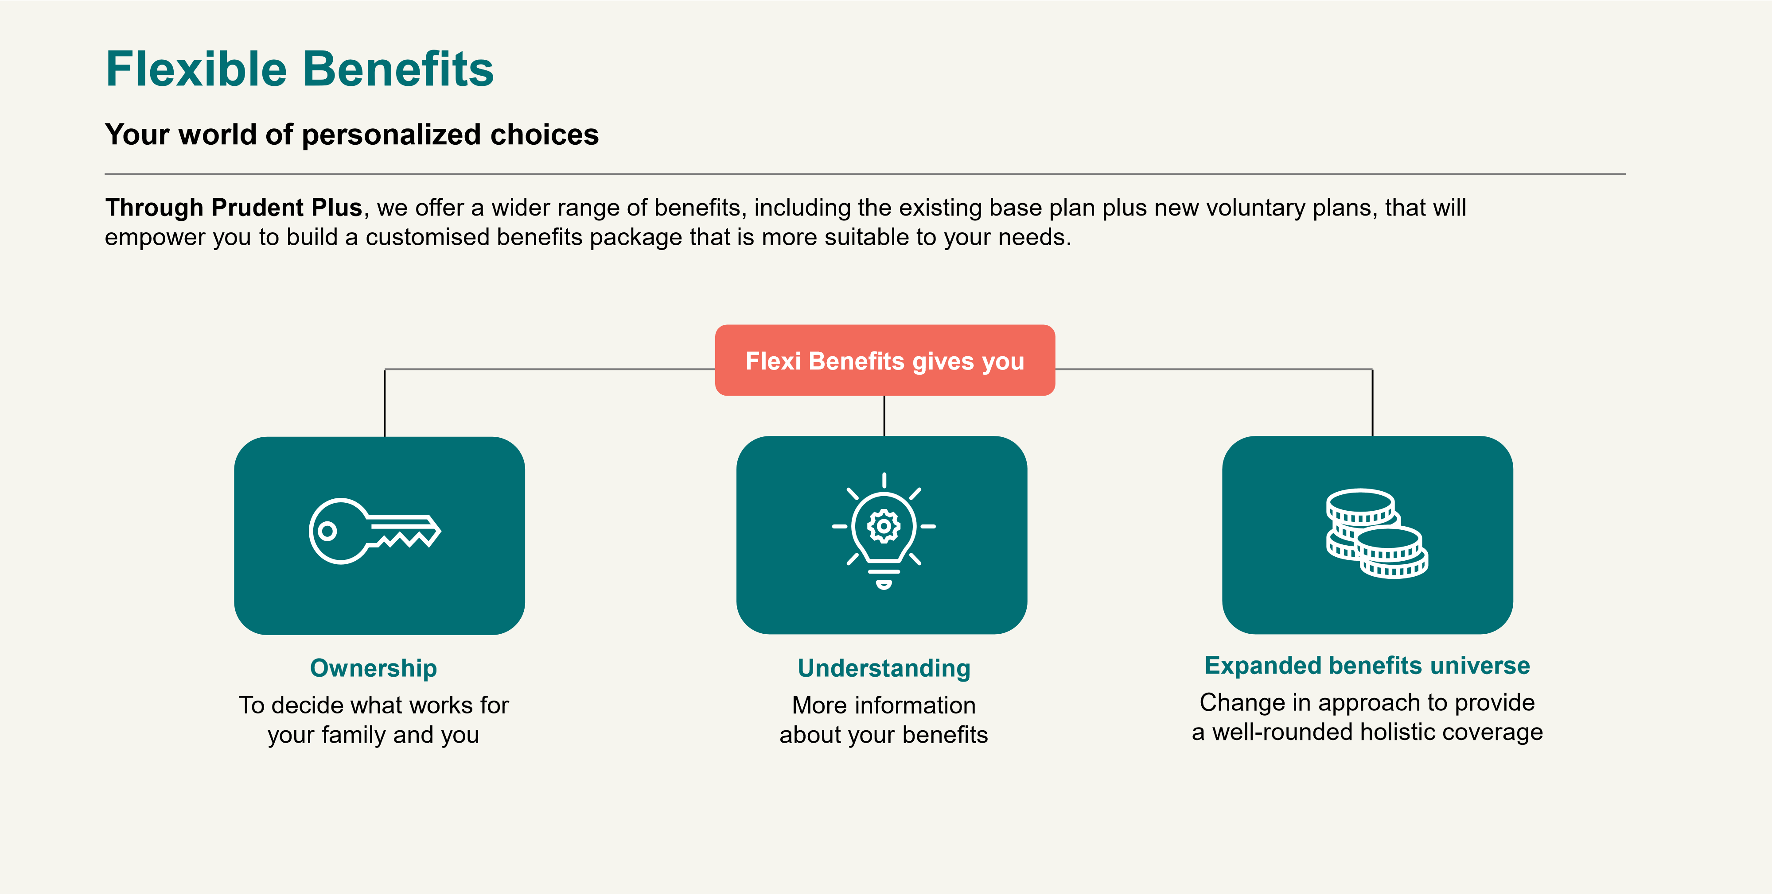

**Choice 1**

**–**

**Health**

**Insurance Benefits**

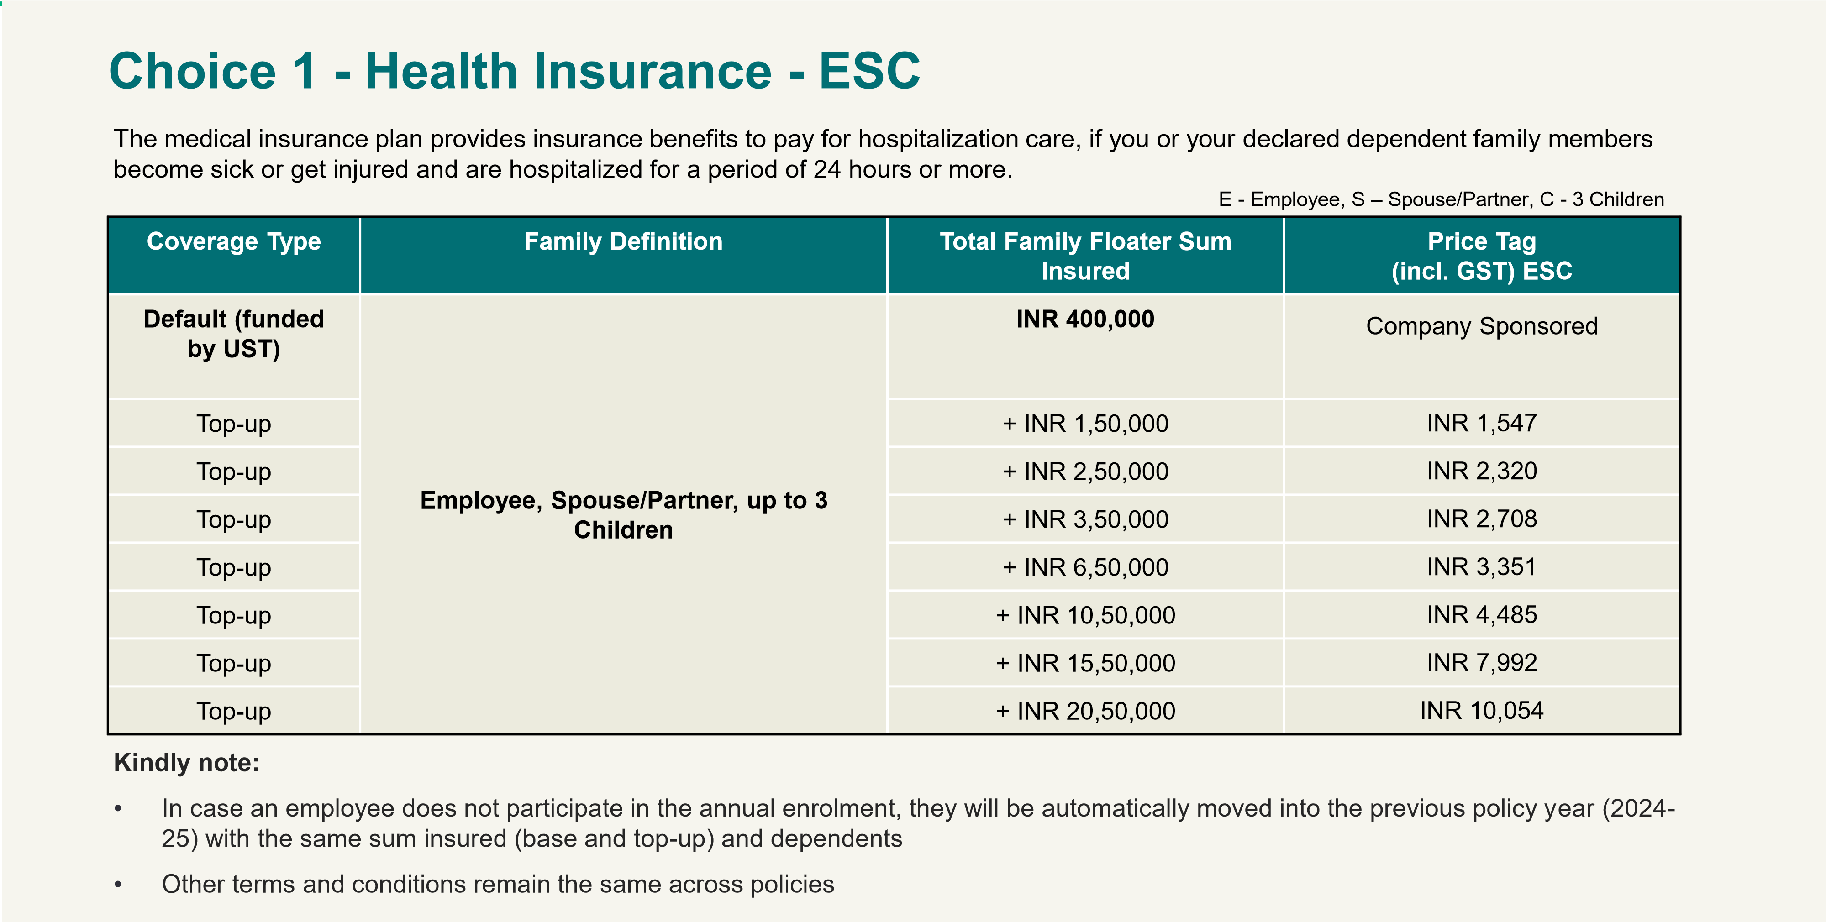

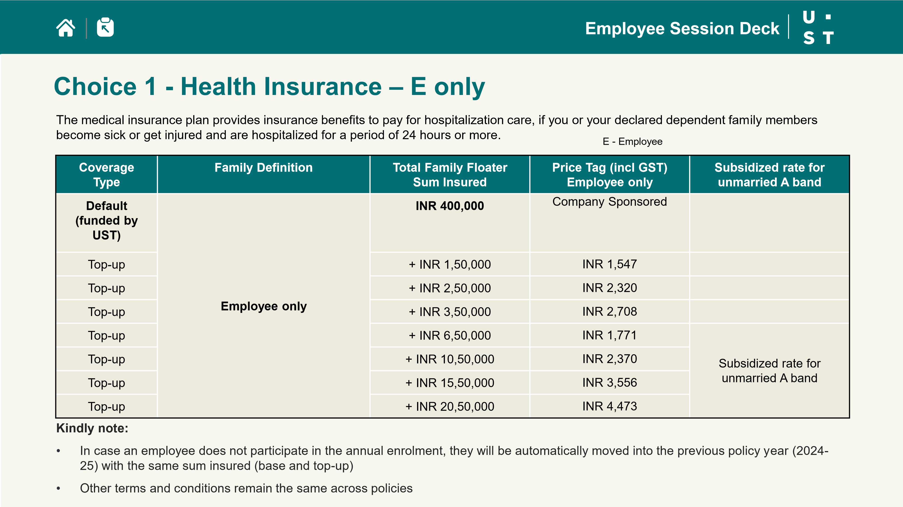

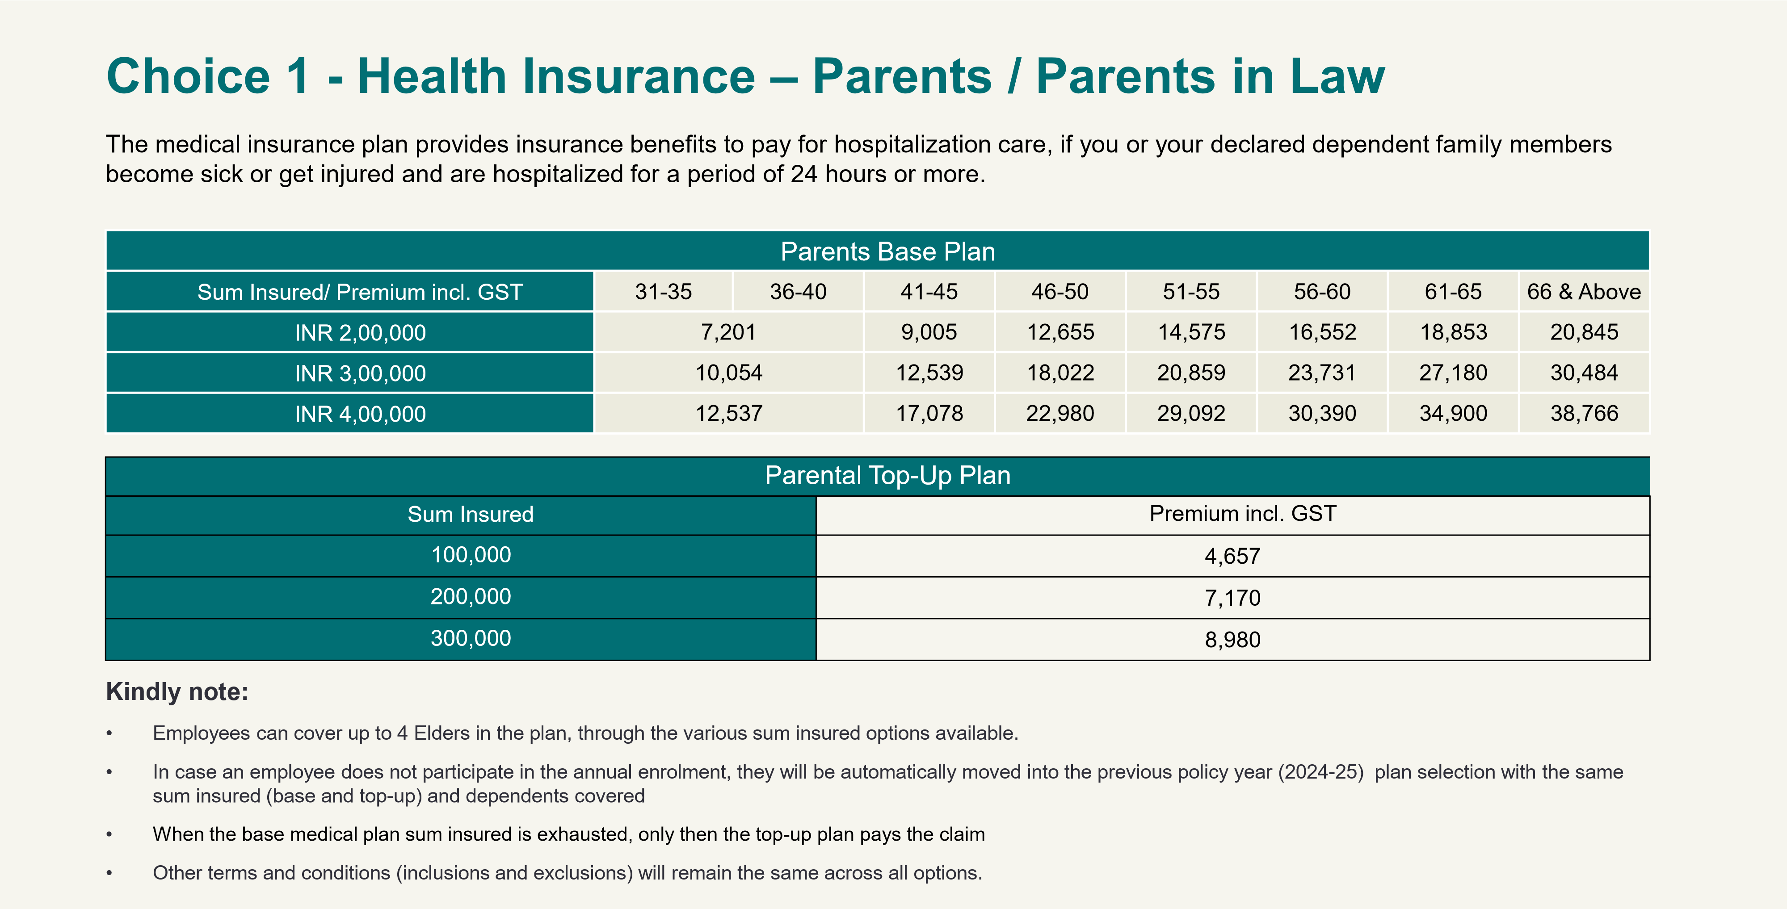

**Choice 2**

**–**

**Additional Module**

•

Employees can choose to make their medical plan more robust by

buying these additional modules

•

These modules gets plugged

-

in as part of the base medical plan

under the eligible sum insured

•

Additional benefits will be extended to employee and the

dependents as covered in the medical insurance plan

Plans are offered by insurance company and

can be availed through reimbursement or

cashless facility.

Employees can select these plans during

annual enrollment only

**How it works?**

**When to choose?**

**Women & Child Care Plan**

**Price**

**-**

**INR 11,210**

**Eligibility: Employee, Spouse, and Child**

•

Cervical Cancer Vaccination (Employee,

Spouse)

–

INR 10,000 (up to 35 years)

•

Higher maternity limit

-

Additional

INR 10,000

•

Higher infertility limit

–

Additional INR

10,000

•

Coverage for PCOD/PCOS treatments up to

INR 20,000 within the full sum insured

•

Cochlear implant co

-

pay reduced to 25%

from 50%

•

Stem cell coverage enhanced to INR 75,000

per family from INR 50,000 within the full

sum insured

•

The price mentioned is per employee rate

**Advance Care Plan**

**Price**

**–**

**INR 5,310**

**Eligibility: Employee, Spouse, and Child**

•

Standalone physiotherapy up to INR 25,000

within the full sum insured

•

Robotic Surgery coverage enhanced to 75%

from 50% of the full sum insured

•

AYUSH cover enhanced to INR 1,00,000 from

INR 50,000 within the full sum insured

•

All hospitalization expenses for the donor are

covered up to the full sum insured

•

Psychiatric disorders coverage enhanced to

INR 1,00,000 from INR 50,000 on IPD basis

for employee and dependents

•

Enhanced pre

-

post

-

hospitalization of 60 and

days, respectively (only in critical illness

90

and accidental claims)

•

The price mentioned is per employee rate

**Parental Care Plan**

**Price**

**-**

**INR 8,095**

**Eligibility: Parents/Parents**

**-**

**in**

**-**

**law**

•

Palliative care covered up to 50% of the

sum insured. Maximum limit of INR

2

,

00,000

•

Robotic Surgery coverage enhanced to

75

% of the sum insured from 50%

•

Standalone physiotherapy up to INR

10

,000 within the full sum insured

•

All hospitalization expenses for the

donor are covered up to the full sum

insured

•

**All forms of IPD/ day**

**-**

**care cancer**

**treatment enhanced by an additional**

**INR 50,000 per family (New)**

•

The price mentioned is per parent rate

**Financial Care Plan**

**Price**

**-**

**INR 29,500**

**Eligibility: Parents/Parents**

**-**

**in**

**-**

**law**

•

Co

-

pay buy back (New copay 0% from

% and 20% respectively

15

)

•

AYUSH cover enhanced to

INR 1,00,000 from INR 50,000 within the

full sum insured

•

Standalone physiotherapy covered up to

INR 10,000 within the full sum insured

•

Care for Parkinson’s, Dementia,

Alzheimer's at home up to 50% of the

sum insured. Maximum limit of INR

00,000

,

1

•

**Enhanced cataract plan limit**

**–**

**INR**

**45**

**,000 from INR 35,000 within the full**

**sum insured**

•

The price mentioned is per parent rate

**Choice 2**

**-**

**Additional Modules (optional selection)**



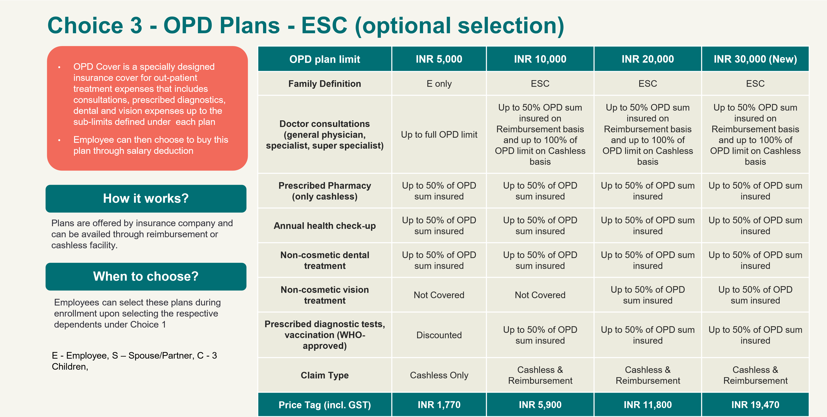

**24**

**Choice 3**

**-**

**OPD Plans**

**-**

**P/PIL (optional selection)**

•

OPD Cover is a specially designed

insurance cover for out

-

patient treatment

expenses that includes consultations,

prescribed diagnostics, dental and vision

expenses up to the sub

-

limits defined

under each plan

•

Employee can then choose to buy this

plan through salary deduction

Plans are offered by insurance company and

can be availed through reimbursement or

cashless facility.

Employees can select these plans during

enrollment upon selecting the respective

dependents under Choice 1

**How it works?**

**When to choose?**

**OPD plan limit**

**INR 10,000**

**INR 20,000**

**Family Definition**

Parents/Parents

-

in

-

law

Parents/Parents

-

in

-

law

**Doctor consultations (general**

**physician, specialist, super specialist)**

Up to 50% OPD sum insured on

Reimbursement basis and up to 100% of

OPD limit on Cashless basis

Up to 50% OPD sum insured on

Reimbursement basis and up to 100% of

OPD limit on Cashless basis

**Prescribed Pharmacy**

**(**

**Cashless only)**

Up to 50% of OPD sum insured

Up to 50% of OPD sum insured

**Annual health check**

**-**

**up**

Up to 50% of OPD sum insured

Up to 50% of OPD sum insured

**Non cosmetic dental treatment**

Up to 50% of OPD sum insured

Up to 50% of OPD sum insured

**Non cosmetic vision treatment**

Up to 50% of OPD sum insured

Up to 50% of OPD sum insured

**Prescribed diagnostic tests,**

**vaccination (WHO**

**-**

**approved)**

Up to 50% of OPD sum insured

Up to 50% of OPD sum insured

**Claim Type**

Cashless & Reimbursement

Cashless & Reimbursement

**Price Tag (incl. GST)**

**INR 7,080**

**INR 12,980**

**Choice 4**

**-**

**Critical**

**Illness**

**26**

**Choice 4**

**-**

**Critical Illness (optional selection)**

•

When a serious illness strikes, Critical Illness insurance can provide financial support to help you through a difficult time

.

•

This plan is applicable for employee only

**Critical Illness**

•

Employee gets a lump sum amount upon diagnosis of the critical illness

•

Helps in managing out

-

of

-

pocket expenses

•

Coverage for critical illnesses, including:

•

First heart attack

•

Cancer of specified severity

•

Kidney failure requiring regular dialysis

•

End

-

stage liver failure

•

Major organ/Bone Marrow Transplant

•

Open Chest CABG

•

Open heart replacement

•

Permanent Paralysis of limbs

•

Stroke resulting in permanent symptoms

•

30

-

day survival period

•

90

-

day waiting period is applicable for first

-

time entrants

**Eligibility**

**Sum Insured**

**Price Tag**

**(**

**incl. GST)**

Employee, Spouse

INR 5,00,000

INR 3,398

Employee, Spouse

INR 10,00,000

INR 6,797

Employee, Spouse

INR 20,00,000

INR 12,234

Employee, Spouse

INR 25,00,000

INR 18,351

Employee

INR 5,00,000

INR 1,888

Employee

INR 10,00,000

INR 3,776

Employee

INR 20,00,000

INR 6,797

Employee

INR 25,00,000

INR 10,195

**Choice 5**

**-**

**Care Plans**

**Choice 5**

**-**

**Care Plans (optional selection)**

•

Plans are offered through a wellness provider

•

You can register for the plan by giving required details on vendor’s website

•

Payment will be done directly by employee using the payment

gateway

•

Premiums

for

care

plans

is

listed

in the

porta

l

You can select these plans any time during the

year. Plans will be applicable for a year from the

date of purchase

**When to choose?**

**How it works?**

**Elder Care Plan**

**Pregnancy Care Plan**

Providing access to

ante

-

natal care,

health content,

nutrition counselling,

and regular

consultation

Physician consult,

telemedicine,

discounted

physiotherapy

sessions/nurse home

visits, curated health

content, second

opinion service

**Holistic well**

**-**

**being**

**Pet Insurance**

Pet Insurance:

Insurance plan,

providing coverage

for surgeries up to

INR

00

,00,

2

0

hospitalization

expenses and

much more

.

Price

Access to online and

at

–

center workouts

across locations

12

-

month plan

CULT Elite

membership

**Cult Fitness Pack**

**Health Check**

**-**

**up**

Comprehensive blood

test including

Complete Hemogram,

Kidney function test,

lipid profile, liver

function test, cardiac,

thyroid, diabetes,

vitamin and mineral

test

**Employee Session Deck**

`

**Choice 5**

**-**

**Care Plans (optional selection)**

•

Plans are offered through a wellness provider

•

You can register for the plan by giving required details on vendor’s website

•

Payment will be done directly by employee using the payment gateway

You can select these plans any time during the

year. Plans will be applicable for a year from the

date of purchase

**When to choose?**

**How it works?**

**Cancer Care Plan**

**Male**

**)**

**(**

Lifestyle risk

assessments,

vaccinations (HPV,

Hepatitis B), age

-

appropriate

screenings for

prostate cancer, and

oral cavity exams.

**Holistic well**

**-**

**being**

**AI Skin Test**

Leverages state

-

of

-

the

-

art

AI and imaging

technologies to perform

comprehensive skin

evaluations. It identifies

various skin conditions and

provides customized

skincare recommendations

based on in

-

depth analysis

Diagnostics like CBC,

Vitamin D 25

Hydroxy, Calcium,

Thyroid Profile,

HbA1c, Lipid Profile,

Hormonal tests: FSH,

LH, Estradiol.

Personalized diet

chart, and tele

-

consultation

**Pre**

**-**

**Menopause Care**

**Employee Session Deck**

**Cancer Care Plan**

**Female**

**)**

**(**

Lifestyle risk

assessments,

vaccinations (HPV,

Hepatitis B), and age

-

appropriate

screenings for breast,

ovarian and cervical

cancer

**Employee Session Deck**

**Standard hospitalisation: 24**

**-**

**hours**

Cashless/reimbursement of expenses related to

▪

Room and boarding

▪

Doctors’ fees

▪

Intensive Care Unit

▪

Nursing expenses

▪

Surgical fees, operating theatre, anesthesia, oxygen, and their

administration

▪

Physiotherapy

-

follow up post

-

hospitalisation

& surgical event

only

▪

Drugs and medicines consumed at the premises

▪

Investigation/diagnostic test such as laboratory, X

-

ray, scans

etc.

▪

Dressing, ordinary splints, and plaster casts

▪

Costs of prosthetic devices if implanted during a surgical

procedure

▪

Radiotherapy and chemotherapy

A hospital or a nursing home means any

institution in India established for indoor care

and treatment of sickness and injuries, and

which has been registered either as a hospital

or nursing home with the local authorities and is

under the supervision of a registered and

qualified medical practitioner, or complies with

minimum criteria, as follows:

1.

Has a minimum of 10 beds if located in

towns having a population of less than INR

Lakhs (class

10

-

C towns) or a minimum of

in

15

-

patient beds in other towns

2.

Has a fully

-

equipped operation theatre

3.

Has a fully

-

qualified doctor

-

in

-

charge and

nursing staff around the clock

4.

Maintains a daily medical record for each of

its patients

**Employee Session Deck**

**Day care procedures**

[**d**](https://prudentplus.co.in/prudent-cms/Documents/DownloadCentral/NIA_Day_Care_List_4.pdf)

[**click here to downloa**](https://prudentplus.co.in/prudent-cms/Documents/DownloadCentral/NIA_Day_Care_List_4.pdf)

General day care procedures

Pre

and post

-

hospitalisation

expenses

**30**

**days**

**pre**

▪

Over 140+ daycare procedures covered under the Mediclaim policy

▪

Kindly refer to the attachment for the list. This may change from time to time, hence, please check with

the TPA prior to the procedure

**60**

**days**

**post**

**Employee Session Deck**

▪

Less than 24

-

hour hospitalization

▪

Circumcision, unless necessary for treatment of disease

▪

All types of dental treatments unless arising from disease or injury and which

required hospitalization for treatment

▪

HIV and AIDS (except self, spouse, & children)

▪

Venereal diseases

▪

Hospitalization for convalescence, general debility, rest cure, intentional self

-

injury, use of intoxicating drugs/alcohol

▪

Naturopathy, homeopathy treatment any other nonallopathic treatment which

is not approved by the policy

▪

Any surgeries/treatments could be performed on an out

-

patient basis by using

local anesthesia intervention

▪

Hospitalization is for only investigation and observation without an active line

of treatment for an ailment

▪

Any non

-

medical expenses like registration fees, admission fees, charges for

medical records, cafeteria charges, telephone charges, disposable items, and

any reusable items consumed at the premises, etc.

▪

Cost of spectacles, contact lenses, hearing aids

▪

Any cosmetic or plastic surgery except for correction of injury caused by

accident

▪

Charges incurred primarily for diagnostic, X

-

Ray, or laboratory examinations

or other diagnostic studies not consistent with or incidental to the diagnosis

and treatment of any ailment, sickness, or injury

▪

Vitamins and tonics unless used for the treatment of injury or disease

▪

Injury or disease caused directly or indirectly by nuclear weapons

▪

Injury or disease directly or indirectly caused by or arising from or attributable

to war or war

-

like situations • And all other expenses that are not payable as

per policy terms and conditions

▪

Doctor’s home visit charges, Attendant/Nursing charges during pre

-

and post

-

hospitalization period

▪

Treatment of obesity or condition arising therefrom (including morbid obesity)

and any other weight control program, services or supplies,

etc

▪

Any treatment required arising from Insured’s participation in

nany

hazardous

activity. Any treatment received in convalescent home. Convalescent hospital

, health hydro, nature care clinic or similar establishments

▪

Cashless & reimbursement claims will not be paid towards the

hospitalisation

taken in Blacklisted Hospital of Insurance company

▪

Please note this list is indicative only

**General Exclusions**

Hospitalization is only for investigation and observation, oral medication without an active line of treatment for an any ail

men

t

-

not

payable in the policy

**Employee Session Deck**

**Cashless Process**

Cashless means the Administrator may authorize upon a Policyholder’s request for direct settlement of eligible services

and

it’s

according charges between a Network Hospital and the Administrator. In such case the Administrator will directly

settle all eligible amounts with the Network Hospital and the Insured Person may not have to pay any deposits at the

commencement of the treatment or bills after the end of treatment to the extent as these services are covered under the

Policy.

**Note :**

Patients seeking treatment under cashless hospitalization are eligible to make claims under pre and post hospitalization

expenses. For all such expenses the bills and other required documents needs to submitted separately as part of the claim's

reimbursement.

Cashless/Reimbursement claims will not be paid towards the hospitalization taken in Blacklisted hospital of Insurance company

**Network Hospital list:**

(

please refer to the website for

the updated list)

For Updated List visit to Medi Assist link as below:

[https://mediassisttpa.in/networ](https://mediassisttpa.in/network-hospital-search/)

[k](https://mediassisttpa.in/network-hospital-search/)

[-](https://mediassisttpa.in/network-hospital-search/)

[hospita](https://mediassisttpa.in/network-hospital-search/)

[l](https://mediassisttpa.in/network-hospital-search/)

[-](https://mediassisttpa.in/network-hospital-search/)

[search](https://mediassisttpa.in/network-hospital-search/)

[/](https://mediassisttpa.in/network-hospital-search/)

**Employee Session Deck**

**Reimbursement**

**Hospitalisation**

**Admission procedure**

•

In case you choose a

non

-

network hospital you

will have to liaise directly

with the hospital for

admission.

•

However, you are

advised to follow the

pre

-

authorization

procedure to ensure

eligibility for

reimbursement of

hospitalization expenses

from the insurer.

**Discharge procedure**

•

In case of non network

hospital, you will be

required to clear the bills

and submit the claim to

Medi assist for

reimbursement from the

insurer. Please ensure

that you collect all

necessary documents

such as

–

discharge

summary, investigation

reports etc. for submitting

your claim.

**Submission of**

**hospitalization claim**

•

You must submit the

final claim with all

relevant documents

within 60 days from the

date of discharge from

the hospital

**Employee Session Deck**

Contact

Matrix

Location POC

**Place**

**Venue**

**POC**

**Contact**

**Frequency**

**Timings**

**TRIVANDRUM**

TRIVANDRUM

UST

CAMP

US (DENTAL RECEPTION

AREA)

Kaimal Balakrishnan

6364871470

MON

-

FRI (except

Tuesday)

9

AM to 6:00 PM

TECHNO PARK BHAVANI

(

EAST 4TH FLOOR

)

Tuesday

9

AM to 6:00 PM

**HYDERABAD**

CYBER PEARL

Kallapelly

Ramesh

8978877244

1

st & 3rd

M

onday

10:00

AM to 05:00

PM

**CHENNAI**

ASV SUNTECH PARK

Preethi

6363020751

All Tuesday

**BANGALORE**

PRESTIGE

SHANTINIKETAN,PRESTI

GE SHANTINIKETAN 9TH

FLOOR

Bharath

9606073616

3

rd

Tuesday

**Kochi**

CARNIVAL INFOPARK &

BRIGADE

Yibnu

Kabir

9072593397

1

st

Friday

**Noida**

UST GLOBAL, INDIA

GLYCOLS LTD COMPLEX

Vicky

8448697095

1

st & 3rd Monday

**Employee Session Deck**

Escalation Matrix

TPA :

**Medi Assist India TPA Pvt. Ltd.**

**Level**

**Name**

**Designation**

**Email Address**

**Phone #**

Level 1

Kaimal Balakrishnan

Executive

kaimal.balakrishnan@mediassist.in

6364871470

Level 2

Preethi D

Executive

preethi.d@mediassist.in

6363020751

Level 3

Arulambeth

Senior Executive

arulambeth.t@mediassist.in

7411500621

Level 4

Balaji AK

Manager

balaji.ak@mediassist.in

7204254940

Level 5

Mohan Raj

Team Leader

raj.mohan@mediassist.in

9035618328

**Level**

**Name**

**Ph. no**

**Mail id**

Level 1

Mubarak S

080

-

692 25407

ustinsurance@prudentbrokers.com

Level 2

Sachin C

080

-

692 25407

ustinsurance@prudentbrokers.com

Level 3

Sonali Bharti

080

-

692 25407

ustinsurance@prudentbrokers.com

Level 4

Mahendran MC

+9197315 89700

mahendran.mc@prudentbrokers.com

**Prudent Escalation Matrix**

**Claims related drop an email to bangaloreclaims@prudentbrokers.com**

